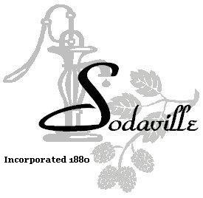

Welcome to the City of Sodaville Water System!

Bills are mailed out on the 10th of each month and are due by the 5th of the following month. If a payment is not received by the 5th a late charge will be applied to the bill. Currently the late charge is $10.00. The City also charges $35.00 for returned checks.

Accounts with overdue balances of 61 days or more will receive a shut off notice and be charged $15.00 for the delivery of the notice. The balance will have to be paid in full within 3 days or water will be turned off.

For your convenience there is a white drop box located at the Park, on the corner under the maple tree, where you may leave your payments or other correspondence. The City only accepts cash or checks, no cards are accepted. This saves you a stamp and it is picked-up every day City Hall is open (Monday - Thursday 10:00 am – 2:00 pm).

Please feel free to contact me with any concerns or questions you may have.

Judy Smith
City Administrator
Sodaville City Hall
541-258-8882

Sodaville@cityofsodaville.org Phone & Fax: 541-258-8882
City Hall Hours: 10am-2pm Mon-Thurs.
“The Sodaville is an equal opportunity provider and employer”

