……….
30723 Sodaville Rd Lebanon, Oregon
June 2019 Volume 6, Issue 19

City Hall (541) 258-8882 Mayor Suzie Hibbert email: sodaville@cityofsodaville.org
Web Address: www.sodaville.org Judy Smith – City Administrator
000000000000…………..000000000000000000000000000000

City Council Meeting City Hall Hours
7:00 pm June 20, 2019 Mon.–Thurs. 10 am–2 pm

CITY UPDATE
At the June 20th City Council meeting at 7:00 pm, there will be a Public Hearing to discuss and accept the 2019-2020 Fiscal Year Budget. A copy is available at City Hall if you would like to review it. A second reading and vote on Ordinance No. 19-02 A BILL FOR AN ORDINANCE AMENDING THE CITY OF SODAVILLE ZONING AND DEVELOPMENT ORDINANCE No. 12-02 TO ALLOW ACCESSORY DWELLING UNITS IN THE RESIDENTIAL ZONE will also take place at that meeting.

The Linn County Housing Rehabilitation Program has funds to help repair homes and septic systems. There are even special programs dedicated to Veterans and Manufactured Homes. Please see the information on the other side of this newsletter or call City Hall for information.

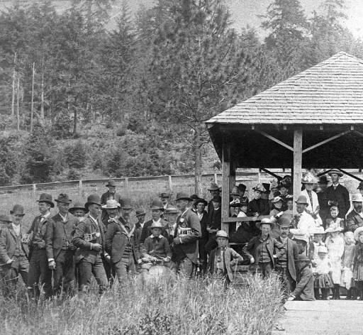
City of Sodaville History: Concert Band
The Sodaville Concert Band, organized in 1891, maintained a membership of 10 to 12, and was well known throughout the county, having playing engagements at Albany, Lebanon, Brownsville, Corvallis, Scio and Newport. It was a success financially as well as musically. Incorporated in 1895, it built a hall in which to hold concerts with accommodations for a general store on the ground floor. The band made its last public appearance at the graduation exercise of the college June 1898, but remained an active organization until the property was sold in 1910.
Judy Smith, City Administrator
MAYOR’S MESSAGE
Have you noticed all the Soda Springs Park improvements? I know some of you do not drive that way through town. Well, you need to come check it out! See the playground equipment going up? That was a 2 day job with day 1 being a learning curve. Now, if we can get more of you out there, things can move along more quickly. We need people to do *heavy lifting *to hold steady the pieces while they are being attached *to be the go-fer *to fix the food *to find the next parts of the project *and I can find other jobs to be done. We have a system down, just need your hands to execute it. Let me know when you are available and we'll schedule some time to get more of you down here.

Part of this GRANT is that WE the CITIZENS of SODAVILLE must put this together.

Thanks to all those who have been volunteering. Your names will be mentioned at the end of the projects. I would love to give a name from every household in Sodaville. Just as it should be.

Sodaville has received another grant of $100,000.00, and that is to pave Washington Street.

One more thing, as the weather gets hot, we use more water. Please be aware of the water you use. The wells are not able to keep up with the high use for very long. If we conserve now, we can stretch out the time before needing to haul in water. The Water grant situation is still in the process with the powers that be as to what is best to do for the City's water system. Stay tuned for more updates!

Take care and see you around!
Suzie mayorhibbert@gmail.com

Public Works Newsletter
The City of Sodaville recently received a complaint about trees blocking roadways along several of the streets in town. In response the City's Public Works Department rented a pole saw and cut the trees back to allow larger vehicles to pass without damaging their equipment. Please be aware that the City's nuisance ordinance 15-03 requires homeowners to keep trees cut back off the roads and to a level of at least fourteen feet in height even if the trees are in the City's right of way. The Public Works Department took on the responsibility this time because of the drastic growth over the last month or two. The Public Works Department will be picking up the debris left behind as time allows. For those of you that would like more information on the City's nuisance ordinance it is available online at www.sodaville.org.

Work is continuing on the Soda Springs Community Center Park. Parking areas have been paved, the restrooms are near completion and volunteers have assembled part of the play structure. More of the play structure will be completed by volunteers on June 8th. The City desperately needs volunteers to complete this project. Following the play structure a swing set and two other toys will be installed followed by many hours of landscaping. If you would like to volunteer your time please give the City a call and we will let you know when the next work day will be. A big thank you to all of the volunteers that have helped with the project so far.

Stan Smith, Public Works Director
Wilda Howard fell and broke her hip. She is now in Avamere Rehabilitation Center 350 8th St, Lebanon, OR 97355, if you would like to send her a card. Get Well Soon Wilda!

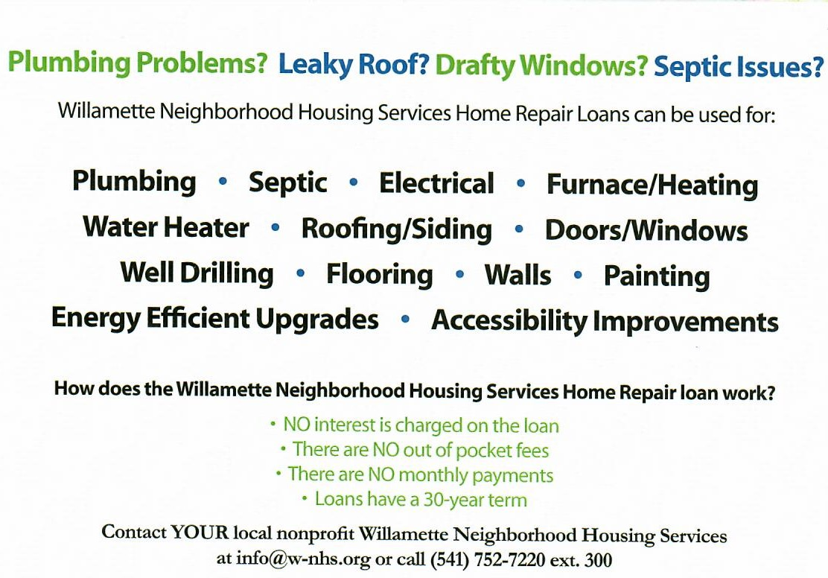

Country Girl Quilting
*Long-arm Machine Quilting
Call Sharon Hill and Joleana Altom at 541-401-7936

Carries Country Inn Adult Foster Home
is located at 30785 Washington Street in Sodaville. “A safe, comfortable home
where you can keep your dignity, respect and independence.”
For information call: 541-570-1430

If you have any announcements, information or ads you wish to have published in the newsletter,
please call before the 6th of the month and I will be happy to insert them!

“The City of Sodaville is an equal opportunity provider and employer.”

