……….
30723 Sodaville Rd Lebanon, Oregon
September 2020 Volume 9 Issue 20

City Hall (541) 258-8882 Mayor Suzie Hibbert email: sodaville@cityofsodaville.org
Web Address: www.sodaville.org Judy Smith – City Administrator
000000000000…………..000000000000000000000000000000

City Council Meeting City Hall Hours
7:00 pm September 17, 2020 Mon. – Thurs. 10 am – 2 pm

CITY UPDATE
I recently received questions regarding the water system and water restriction. Currently there is a WATER RESTRICTION (flyer included in envelope). Please note below what Public Works Director Stan Smith says about conservation efforts. The City is still working on getting a supplemental well or building a pipeline from Lebanon. The USDA requires an Alternative Study be done to look at all possibilities along with costs before they will invest funds for a project. Carollo Engineering has been working on a report and should have it ready in the next couple of months. There have been meetings with representatives of USDA, the Governor’s Regional Task Force, Linn County, the City of Lebanon and Carollo Engineering and all alternatives are being discussed as well as possible funding.
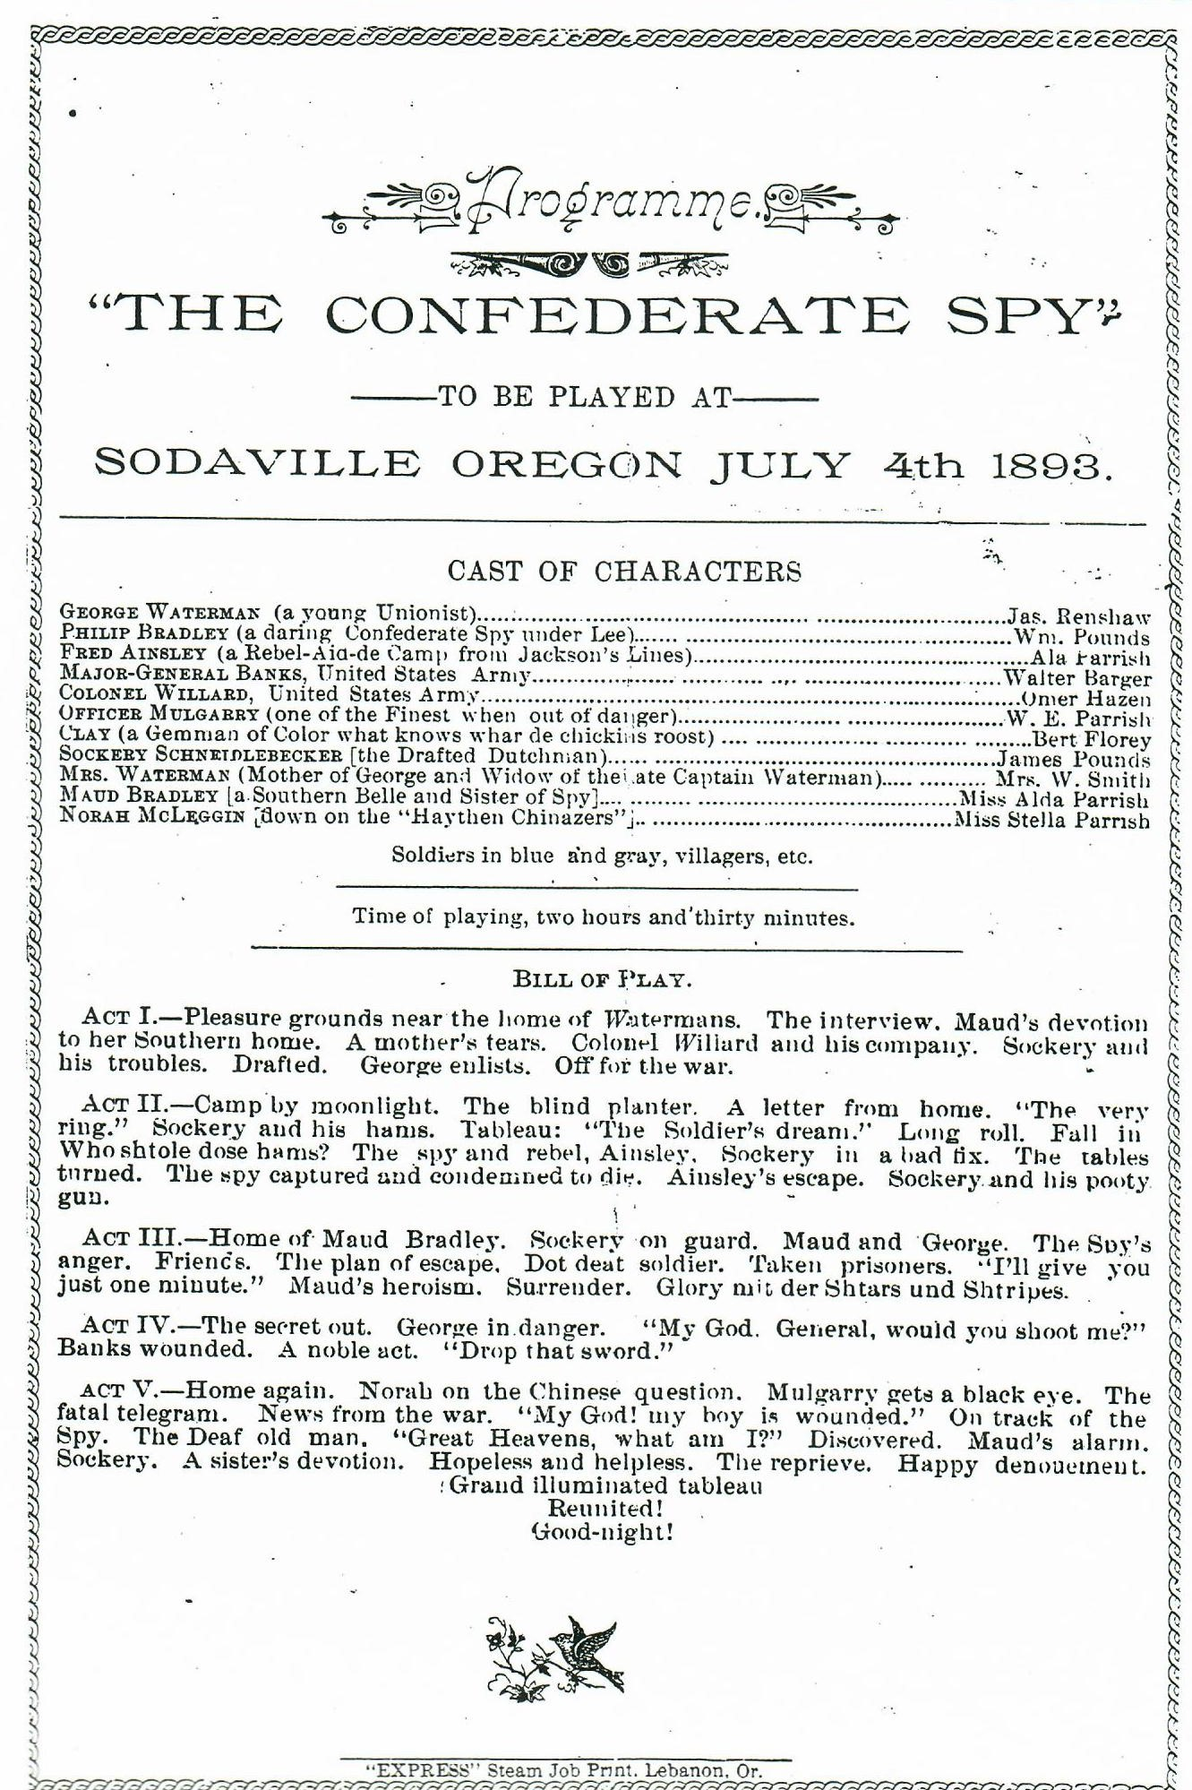
History of Sodaville :

July 4, 1893
The climax of the day was the drama, “The Confederate Spy, given in the evening at Hills Hall. Admission charge was: reserved seats 35 cents; common, 25 cents; children 10 to 15, 15 cents; under 10 admitted free. Each band man was permitted to bring his lady without charge. Takin their part in the play were 8 members of the band and 3 of their sisters. Time of playing was 2 hours and 30 minutes. Act V ended with “the reprieve; happy denouncement; grand illuminated tableau; reunited!”

Judy Smith, City Administrator
(cell: 541-905-2590)

MAYOR’S MESSAGE
September is sure an interesting month!
The wells are slowing down and we need your help to conserve water. We are now implementing Water Restrictions. So please be diligent in watching for leaks and get them repaired as soon as possible. We held off as long as we could. By doing your part of not overusing the water it will help. Remember once the restrictions are in place any leaks or outside water use (limited garden watering allow) is a $500 fine.

As you should have seen by now, I am not running for Mayor this time. I would love to finish strong with having the park completed. The last piece on my project is the fence around the sport court. Everything is ready to roll. I had 8 more hard working people come and spend 5 ½ hours to complete the painting of the posts! It was taking Stan and me years to find time to focus on that project.
WELDERS NEEDED to finish this project. We’ve had a few people offer to weld in the past and they were waiting until the poles were painted. I cannot remember who. Please if you have a welder, and the problem is you do not enough power to run it, the City will rent a suitable generator to get it done. Please, please help me finish this up! The actual job is welding the fence posts together then we can add the chain link fence. We are so close to being done, and I cannot do it alone! Please contact the office or me to schedule when we can do this.
See you around!
Mayor Suzie Hibbert

Public Works Newsletter
With the addition of several new residents this past year water use is at an all-time high. While the City of Sodaville is currently working on solutions to their summer time water issues they are still a ways away from being decided. Current water use this last month averaged about 20,200 gallons per day compared to about 17,000 gallons at this time in 2019 and even less in prior years.

In the June newsletter this year I introduced some ways to cut back water use by reusing water from baths or dish washing to water your garden and flowers. This tip was given to the City by one of the residents of Sodaville. Listed below are some other tips to reduce your water consumption.

• Take your car to the car wash. They recycle their water.
• Turn off faucets while washing your hands.
• Plant native plants that are drought tolerant.
• Reduce your flow at the faucet when washing dishes.
• Take short showers not baths.
• If you have a well on the property use it for outside watering.
• Become inventive. Think about how you can use less water every time you turn on the faucet.

These are just a few items anyone can use to reduce water use and help keep the water flowing.
Stan Smith, Public Works Director
Country Girl Quilting
*Long-arm Machine Quilting
Call Sharon Hill and Joleana Altom at 541-401-7936
Carrie’s Country Inn Adult Foster Home
is located at 30785 Washington Street in Sodaville. “A safe, comfortable home
where you can keep your dignity, respect and independence.”
For information call: 541-570-1430
If you have any announcements, information or ads you wish to have published in the newsletter,
please call before the 6th of the month and I will be happy to insert them!
“The City of Sodaville is an equal opportunity provider and employer.”

